[Nginx setup](https://confluence.renesas.com/display/GMANUF/Nginx+setup)

**Local Setup Nginx on a Windows**

1. **Download Nginx**:  Download the latest stable version of Nginx for Windows. <https://nginx.org/en/download.html>  **nginx-1.24.0**
2. **Extract the Nginx files:**After downloading, extract the contents of the zip file to a directory on your local machine, for example **C:\Users\a5143522\nginx\nginx-1.24.0**
3. **Start Nginx:**
   * Open Command Prompt as an administrator.
   * Navigate to the directory where you extracted Nginx, e.g., **C:\Users\a5143522\nginx\nginx-1.24.0**
   * Start Nginx by running the following command:  **nginx**

1. **Test Nginx:**
   * Open a web browser and navigate to <http://localhost> or <http://127.0.0.1>. You should see the default Nginx welcome page if everything is set up correctly.

1. **Stop Nginx:**
   * To stop Nginx, you can press Ctrl + C in the Command Prompt window where Nginx is running, or you can run the following command in a new Command Prompt window: **nginx -s stop**
2. **Configuration:** Configure Nginx according to your requirements. You can adjust settings like server listening ports, server names, root directory, etc.
   * Navigate to the conf directory inside the extracted Nginx folder.
   * Open the nginx.conf file using a text editor like Notepad and add a new server block to configure the proxy.

* + This configuration sets up a reverse proxy for requests to /api/server and forwards them to <http://gymservicestagefra.adwin.renesas.com>.

1. Test the Configuration: Before applying the changes, it's a good idea to test the Nginx configuration to ensure there are no syntax errors. Run the following command: **nginx -t**

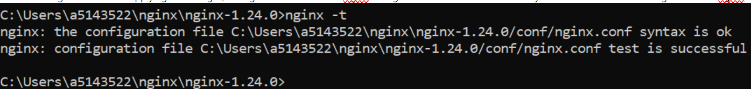

1. **Restart/Reload  Nginx:**
   * To restart Nginx after making configuration changes, run the following command in the Command Prompt window: **nginx -s reload**
2. **Make a Test Call:** You can now make a test call to the configured endpoint using a tool like curl or by accessing the URL in a web browser. For example: **curl** [**http://localhost/api/server**](http://localhost/api/server)   This setup will forward requests to[**http://localhost/api/server**](http://localhost/api/server) to <http://gymservicestagefra.adwin.renesas.com/api/server>.